

**AI Smart للعقارات**

**Software Development Plan For Smart للعقارات**

***Faculty of Computer and Information***

***Luxor University***

**Project Advisors:**

**Dr. Mohamed Ramadan.**

**Eng. Mohamed Ahmed Mohamed.**

**Submitted by:**

**1) Mohamed AbdElrahman Elkhlawy**

**2) Waleed AbdElmeged Alassar**

**3) Mohamed Roshdy Tawfik Soliman**

**4) Samar Sayed AbdElaal**

**5) Mohamed Gabrallah Sayed**

**6) Yasser Ayman**

**Date: 21/5/2023**

# ABSTRACT

**The Apartment Rental project aims to develop a web-based platform that simplifies the process of renting apartments for both tenants and property owners. The project's primary objective is to create an efficient and user-friendly system that facilitates the search, booking, and management of rental properties. By leveraging modern technologies and a comprehensive set of features, the platform seeks to streamline the rental process, enhance transparency, and provide a seamless experience for all stakeholders involved.**

**This documentation serves as a comprehensive guide that outlines the project's objectives, scope, requirements, architecture, and implementation details. It includes various sections such as the project proposal, requirements analysis, system design, testing plan, risk management, and data dictionary. Each section provides valuable insights and guidelines for successfully developing and deploying the Apartment Rental system.**

**By following this documentation, the project team can ensure a structured and efficient development process, resulting in a high quality and reliable solution. It serves as a reference point for project stakeholders, including developers, testers, designers, and project managers, enabling them to understand the project's vision, requirements, and technical specifications.**

**With a clear understanding of the project's goals and deliverables, the Apartment Rental system has the potential to revolutionize the rental market, providing a modern, streamlined, and transparent platform for both tenants and property owners.**

# TABLE OF CONTENTS

## 1. PRODUCT DESCRIPTION

### Product Description

**Our project is a site for selling and renting apartments and displaying all the details of the apartment in terms of location, price, and interior details of the apartment, in addition to pictures, videos, and any other details that the user may need.**

### Client Description

**Our client is a real estate rental company that operates in the property sector. The company aims to provide high quality and reliable rental services for apartments and properties to its clients. The company is committed to offering a unique rental experience to its clients, where quality and high-level service are the primary focus.**

**Services:**

**The company provides a variety of rental services related to properties, including:**

**1- Residential and commercial apartment rentals of different sizes and specifications.**

**2- Consulting services related to property rentals, including guidance and advice for clients on suitable properties, pricing, and other matters related to property rentals.**

**Objective:**

**The company aims to provide a high quality and reliable rental experience for its clients, with the goal of achieving customer satisfaction and ensuring their return in the future. The company also aims to increase brand awareness, expand its customer base, and achieve sustainable profits and growth in the market.**

### User Requirements

1. **The website should be designed with a simple and user-friendly interface that allows users to easily access services.**
2. **Advanced search functionality should be provided, allowing users to search for available properties based on various criteria such as location, price, area, type, etc.**
3. **A tool for users to upload and download photos of properties should be provided.**
4. **Users should have the option to add comments and ratings about properties.**
5. **A system for managing properties and related financial transactions should be provided, including advertising properties and obtaining contact information for owners.**
6. **There should be a user account management interface where users can modify their personal information and manage their properties.**
7. **The site should be compatible with various devices and platforms, including computers, smartphones, and tablets.**
8. **Notification feature should be provided to users, where they receive notifications including site updates and new properties.**
9. **The feature of providing the numbers of the owners and accredited brokers must be provided through the site, to facilitate the process of communication between them**
10. **Language options should be provided to accommodate different users.**

### Domain Requirements

1. **The website must comply with all local and international real estate laws and regulations.**
2. **The website must support multiple languages to cater to a global audience.**
3. **The website should have a user-friendly interface to enhance the user experience.**
4. **The website should provide comprehensive information on properties, including price, location, and specifications.**
5. **The website must provide users with an easy-to-use search function to help them find properties quickly and easily.**
6. **The website must provide real-time updates on property availability and prices.**
7. **The website should have a reliable and efficient customer support system to address user inquiries and complaints.**
8. **The website must have a backup and disaster recovery plan to ensure the availability of the service in the event of a system failure.**
9. **The website must adhere to high standards of data privacy and security to protect users' personal information.**

### Non-Functional Requirements

1. **Performance: The website must be able to handle a high volume of traffic without experiencing slow page loading times or crashes.**
2. **Security: The website must be designed with appropriate security measures to protect user data and prevent unauthorized access.**
3. **Usability: The website must be easy to navigate and use for users with different levels of technical proficiency.**
4. **Availability: The website should be available 24/7 without any downtime or disruptions to service.**
5. **Reliability: The website must be able to perform its functions without errors or failures, even under heavy usage or traffic.**
6. **Scalability: The website should be designed to accommodate growth and increasing traffic and usage over time.**
7. **Compatibility: The website must be compatible with different browsers, operating systems, and devices to ensure a broad range of accessibility.**
8. **Accessibility: The website must be designed to comply with accessibility standards and provide equal access to all users, including those with disabilities.**
9. **Maintainability: The website must be easy to maintain and update, with code that is well organized and documented.**
10. **Performance efficiency: The website should be designed to consume minimal resources and operate efficiently to reduce server load and minimize energy consumption.**

### Non Requirements

1. **Designing, constructing, and managing physical properties, including buildings, is not part of this project.**
2. **This project does not include any legal advice or services related to real estate transactions.**
3. **The system will not be responsible for any inaccuracies or errors in the data provided by third-party sources.**
4. **The system does not guarantee the availability or accuracy of property data, as this data is subject to change without notice.**
5. **The system does not include any marketing or advertising services for the properties listed on the platform.**
6. **This project does not include any services related to property insurance or risk management.**
7. **The system does not provide any warranties or guarantees for the properties listed on the platform.**
8. **The project does not include any services related to property management, such as tenant screening or lease management.**
9. **The system is not responsible for any damage or loss of data due to technical failures or other reasons beyond its control.**
10. **This project does not include any services related to property valuation or appraisal.**

### Audience and Goals

#### **Audience:**

**The target audience for the real estate rental company includes individuals and families looking to rent apartments or properties. The company may also target business professionals, international students, and expats who require temporary housing.**

#### **Product Goals:**

1. **To provide a wide range of rental properties that cater to the diverse needs and budgets of its customers.**

**2. To establish the company as a trusted and reliable brand in the real estate rental market, with a strong reputation for customer satisfaction.**

**3. To grow the company's customer base and market share through effective marketing strategies and word-of-mouth referrals.**

**4. To maximize profits while maintaining competitive pricing to ensure that the company's rental properties remain accessible to a broad range of customers.**

# 2. TEAM DESCRIPTION

|  |  |  |  |  |
| --- | --- | --- | --- | --- |
| Member Name | First Skill | Second Skill | Third Skill | Fourth Skill |
| محمد عبد الرحمن احمد الخلاوى | Documenter | Presentator | UML Designer | Fluent in English both Oral and Written |
| وليد عبد المجيد الاعصر | Full Stack Developer | Experience in AI and Machine Learning |  |  |
| محمد رشدى توفيق سليمان | Front End | Documenter | UML Designer | Technical Support |
| سمر سيد عبد العال | Full Stack Developer. | Low Experience in AI | UML Designer |  |
| محمد جبرالله سيد | Back End | Low Experience in Front End | UML Designer |  |
| ياسر ايمن | Documenter | Speaker | Bug Hunter |  |

# 3. SOFTWARE PROCESS MODEL DESCRIPTION

**The Apartment Rental project will follow an iterative and incremental software development process model. The chosen process model provides flexibility and adaptability, allowing for continuous improvement and refinement of the system throughout its development life cycle.**

**The iterative and incremental model consists of multiple iterations or increments, where each iteration focuses on delivering a specific set of features or functionality. This approach enables the development team to gather feedback, incorporate changes, and make improvements based on user requirements and evolving market needs.**

**The development process will be divided into the following phases:**

**1. Requirements Gathering: In this phase, the project team will engage with stakeholders to gather and analyze the requirements for the Apartment Rental system. This involves understanding the needs of tenants, property owners, and administrators, and defining the core functionalities and features of the platform.**

**2. Design and Architecture: Once the requirements are established, the system's architecture and design will be planned and documented. This includes defining the database schema, user interface layout, and system components. The design phase will focus on creating a scalable, modular, and user-friendly system.**

**3. Implementation and Testing: The development team will start implementing the system based on the defined architecture and design. The implementation will be carried out in iterations, with each iteration focusing on implementing a specific set of features. Throughout the implementation phase, comprehensive testing will be conducted to ensure the functionality, reliability, and performance of the system.**

**4. Review and Feedback: After each iteration, a review process will be conducted to gather feedback from stakeholders, including tenants, property owners, and administrators. This feedback will be used to refine and improve the system in subsequent iterations.**

**5. Deployment and Maintenance: Once all the required features are implemented and tested, the system will be deployed to a production environment. Continuous monitoring and maintenance activities will be carried out to ensure the system's stability, security, and performance. Updates and enhancements based on user feedback and changing market trends will be incorporated into the system in subsequent releases.**

**By adopting an iterative and incremental process model, the Apartment Rental project can deliver a robust and user-centric solution. This approach allows for flexibility, adaptability, and continuous improvement, ensuring that the final product meets the evolving needs of tenants, property owners, and administrators in the rental market.**

## 4. PRODUCT DEFINITION

**Context Diagram**

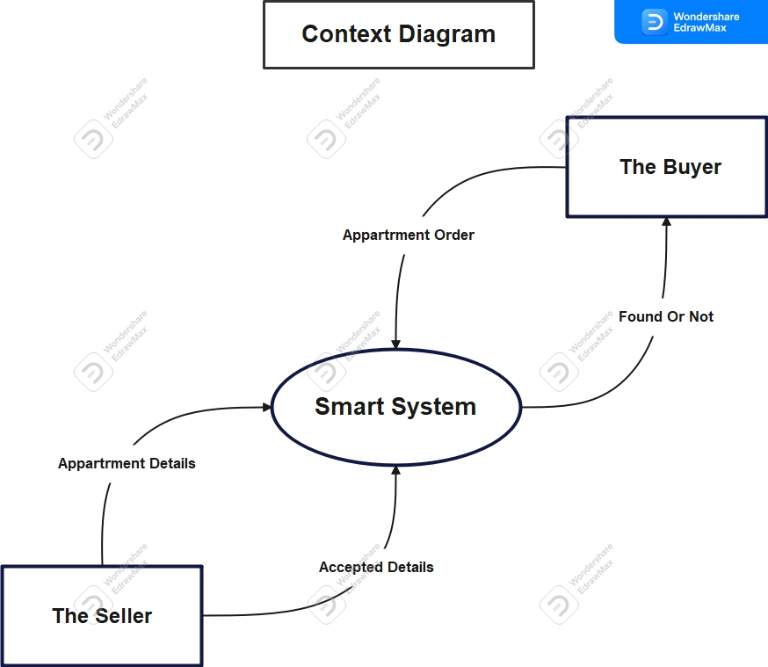

**Persons**

**1) The Buyer: This user deals with the system and searches for apartments with different details.**

**2) The Seller: This user deals with the system and uploads the details of the real estate in addition to some pictures and videos of the property.**

**3) System Admin: He is an advanced type of user, as he is characterize by additional powers such as modifying real estate details, solving problems facing the system, and solving problems of other users.**

**User Stories**

**1) As a renter, I want to be able to search for apartments by location, price, number of bedrooms/bathrooms, look at the photos and videos of apartment and amenities so that I can find the right apartment for my needs.**

**2) The ability to communicate with the landlord to visit the apartment, evaluate it and agree it, and agree on the details of the real estate.**

**3) As a renter, I want to be able to rate and review the apartment and landlord/property manager through the app so that other renters can benefit from my experience.**

**4) As a seller, I want to be able to create a listing for my apartment, including photos, descriptions, and pricing, so that potential buyers can view my property online.**

**5) As a seller, I want to be able to communicate with potential buyers to answer any questions they may have about the property.**

**High Level Use Cases**

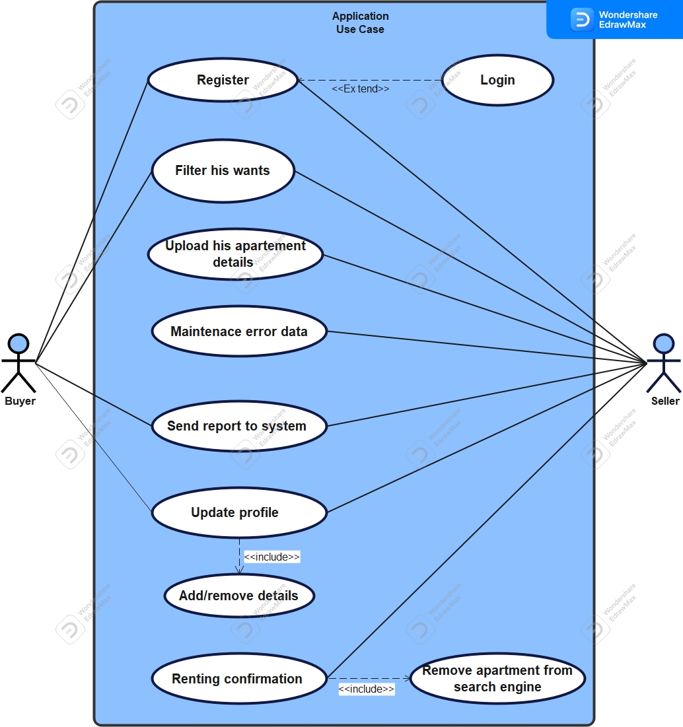

**Figure 1. Application Use case.**

### 

**Figure 2. Admin Dashboard Use case.**

### Use Case Descriptions:

|  |  |
| --- | --- |
| **Use case name** | **Register, Login.** |
| **Area** | **Application.** |
| **Actor(s)** | **Buyer, Seller, System Admin.** |
| **Entry Conditions** | **User isn’t logged in or signed up to our website.** |
| **Exit Conditions** | **User already logged in to his or her account, or signed up and make an account for the first time.** |
| **Flow of Events** | **1) The user opens our website**  **2) If he already has an account he login with his account.**  **3) If not logged in before he will sign up for the first time.**  **4) If he will sign up, he will enter his username and password and rewrite password for confirmation and some data about this user.**  **5) After sign up, he will make login with his account and password.**  **6) If the account and password is correct he will enter the website with his account, else he will get an error message to make a login again.** |
| **Special Requirements** | **1) He did not sign up before, so he will go to sign up process.**  **2) He made a sign up before, so he will go to log in process.** |

|  |  |
| --- | --- |
| **Use case name** | **Filter his wants.** |
| **Area** | **Application.** |
| **Actor(s)** | **Buyer, Seller.** |
| **Entry Conditions** | **Each user needs to login to his account.** |
| **Exit Conditions** | **Each user after searching about his wanted details he will terminate the search process.** |
| **Flow of Events** | **1) The user goes to the search page after finishing the log in process.**  **2) User start to use the filters in the website that match with the details that he wants to know.**  **3) After he finishes the search process and reach to his wanted details, he will terminate the search page.** |
| **Special Requirements** | **1) For Buyer he will search for an apartment with his preferred details to find the appropriate one for him.**  **2) For Seller he will search to know more details about the prices and details for the apartments in this region before upload his apartment details.** |

|  |  |
| --- | --- |
| **Use case name** | **Upload his apartment details.** |
| **Area** | **Application.** |
| **Actor(s)** | **Seller.** |
| **Entry Conditions** | **Seller needs to log in to his account.** |
| **Exit Conditions** | **After the seller upload his apartment details and get the process accept message, he terminates this process** |
| **Flow of Events** | **1) The seller go after finishing the searching process, he goes to the uploading page**  **2) He starts to put his apartment details like location, price, number of bedrooms/bathrooms, and any interior details for the apartments**  **3) He also upload some photos and videos for the apartment**  **4) Finally, he will add ways to communicate with him, like his number or social media pages and so on** |
| **Special Requirements** | **-The seller has an apartment and want to rent or sell it, so he uploads its’ details on our website to be viewed with any one wants an apartment and his details match with its’ detail.** |

|  |  |
| --- | --- |
| **Use case name** | **Maintains error data.** |
| **Area** | **Application.** |
| **Actor(s)** | **Seller, System Admin.** |
| **Entry Conditions** | **Seller and System Admin needs to log in to their accounts.** |
| **Exit Conditions** | **After the seller or system admin finishes the maintenance process, they will terminate the process** |
| **Flow of Events** | **1) If there were any failure in details and the admin catch it, he will hide this apartment from the search engine**  **2) The admin communicates with the seller of this apartment and tell him about the failure details**  **3) The seller then goes to correct the failure in the information of his apartment**  **4) Then admin check the information again if it became right, admin will make it available in the search engine again**  **5) If the seller did not correct it until a specific time, the admin will delete this apartment from the website forever** |
| **Special Requirements** | **- If there is any failure information about any apartment, the maintenance process should done by the system admin and the seller of this apartment, to give other users a reliable information about the apartments.** |

|  |  |
| --- | --- |
| **Use case name** | **Send report to system.** |
| **Area** | **Application.** |
| **Actor(s)** | **Buyer, Seller.** |
| **Entry Conditions** | **Buyer and Seller needs to log in to their accounts.** |
| **Exit Conditions** | **After the buyer or the seller make his report and sends him to the system, this process ends** |
| **Flow of Events** | **1) If the buyer or the seller found any problem or something happen with him on the system or with another user**  **2) This user starts to make a report**  **3) In this report he explains the problem that happens with him in details and ask for help in this problem**  **4) Finally, he submits this report and sends it to the system** |
| **Special Requirements** | **-If any user faces any problem with our system, he immediately starts to make a report about this problem to be solved in a short time**  . |

|  |  |
| --- | --- |
| **Use case name** | **Update user profile.** |
| **Area** | **Application.** |
| **Actor(s)** | **Buyer, Seller.** |
| **Entry Conditions** | **Buyer and Seller needs to log in to their accounts.** |
| **Exit Conditions** | **After the buyer or the seller make his report and sends him to the system, this process ends.** |
| **Flow of Events** | **1) The user opens the website**  **2) Then he goes to his profile**  **3) Then he starts to edit his information on his profile to make it up to date**  **4) Finally, he submits the changes to be update with his profile** |
| **Special Requirements** | **-If any user has any changes on his profile information, then he should edit his profile to be up to date with his new information**  . |

|  |  |
| --- | --- |
| **Use case name** | **Renting confirmation for buyer.** |
| **Area** | **Application.** |
| **Actor(s)** | **Buyer, Seller.** |
| **Entry Conditions** | **Buyer and Seller needs to log in to their accounts.** |
| **Exit Conditions** | **After the seller confirm the renting or buying process on the website, it is process terminated.** |
| **Flow of Events** | **1) The seller opens the website first.**  **2) Then goes to the confirmation process for this apartment.**  **3) Finally, he confirms that this apartment had been sold to remove it from the search engine.** |
| **Special Requirements** | **- If the seller has found a buyer and they reached to an agreement about this apartment, and then he must go to the website to confirm that this apartment has been no longer available to be rent or sell.**  . |

|  |  |
| --- | --- |
| **Use case name** | **Manage Profiles.** |
| **Area** | **Admin Dashboard.** |
| **Actor(s)** | **System Admin.** |
| **Entry Conditions** | **System Admin needs to log in to his account.** |
| **Exit Conditions** | **After system admin complete the management of system data successfully, this process terminates.** |
| **Flow of Events** | **1) Usually, system admin checks the data integrity of the system.**  **2) If there are any problems with system data.**  **3) System Admin check the backup data immediately.**  **4) If backup data is safe, he starts to restore the missed data from the backup.**  **5) If he catches any warnings or illegal actions on the data, he immediately closes any access to the system data, until make sure from the safety of the data actions.** |
| **Special Requirements** | **-The data should be checked daily to make sure from its’ safety, and if there were any illegal actions on the system data, immediately close the access to this data.** |

|  |  |
| --- | --- |
| **Use case name** | **Data Management.** |
| **Area** | **Admin Dashboard.** |
| **Actor(s)** | **System Admin.** |
| **Entry Conditions** | **System Admin needs to log in to his accounts, and there is a user even a seller or buyer whose account make illegal action on the system.** |
| **Exit Conditions** | **After system admin delete the account that do illegal actions, this process terminated.** |
| **Flow of Events** | **1) First, the admin will get a report or catch an account doing illegal actions on the system or anything that is unavailable on our system**  **2) Admin will track the actions of this account to make sure from the reports he got**  **3) If the admin makes sure that this account doing illegal actions, he will remove it immediately from the system** |
| **Special Requirements** | **-If the admin knows that there is an account doing illegal actions on the system, immediately he takes the action and remove it from the system.**  . |

# 5. USER EXPERIENCE WIREFRAMES

### UX Interfaces:

#### **1) Login Page:**

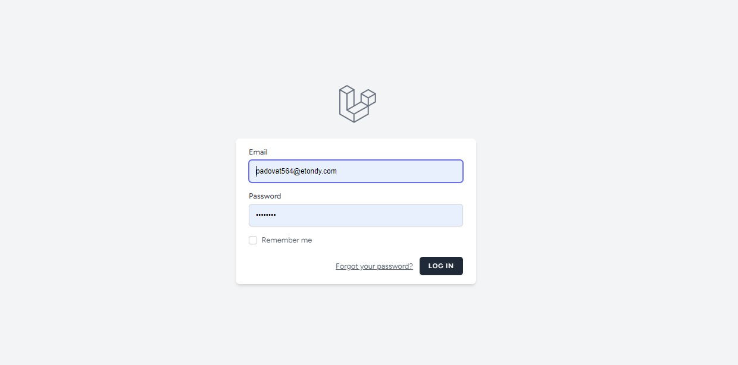

#### **2) Registration Page:**

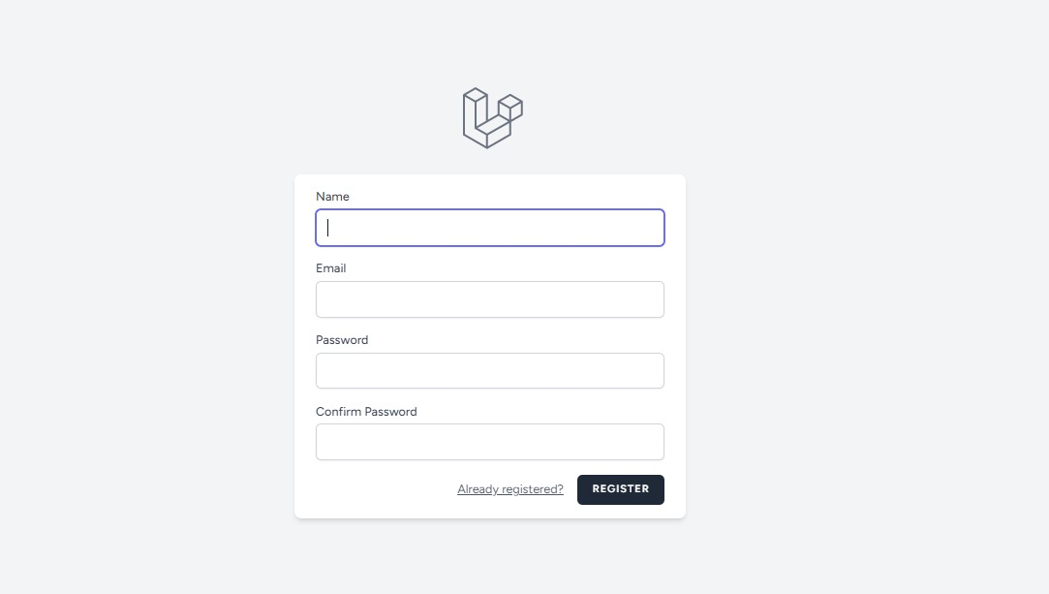

#### **3) Contact with Us Page:**

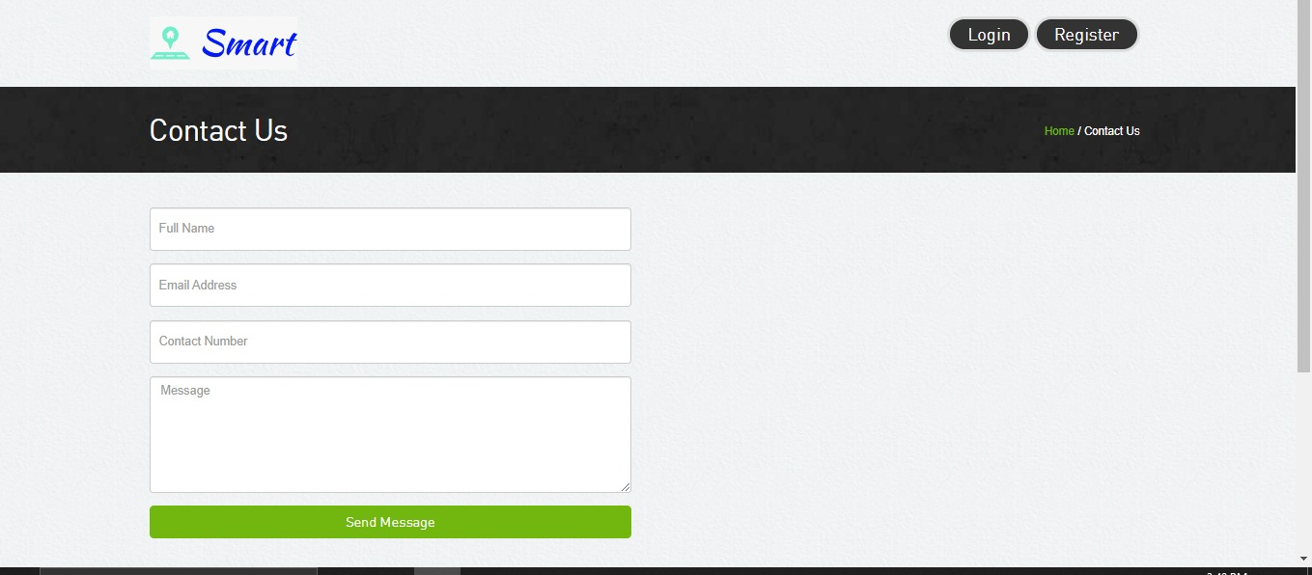

#### **4) About Us Page:**



#### **5) Home Page1:**

#### **6) Home Page2:**

# 6. PROJECT ORGANIZATION

#### **1) Website Development (6-8 weeks)**

* **Design and develop a user-friendly website with search functionality**
* **Implement a system for sellers to upload their properties and manage their listings**
* **Set up a system for buyers to search for properties and communicate with sellers**

#### **2) Marketing and Advertising (3 weeks)**

* **Develop marketing strategies to attract potential sellers and buyers**
* **Advertise through various channels such as online ads, social media, and search engines**
* **Offer promotions and discounts to encourage sellers to list their properties on your website**

#### **3) Seller Management (Ongoing)**

* **Provide support to sellers by answering questions and addressing concerns**
* **Ensure that all uploaded properties meet your website's standards and guidelines**
* **Regularly update and maintain seller accounts and listings**

#### **4) Buyer Management (Ongoing)**

* **Provide support to buyers by answering questions and addressing concerns**
* **Regularly update and maintain buyer accounts and search results**
* **Offer additional services such as property inspections or financing options to enhance the buyer experience**

#### **5) Property Management (Ongoing)**

* **Provide support to sellers and buyers by answering questions and addressing concerns**
* **Ensure that all uploaded properties meet your website's standards and guidelines**
* **Manage the rental or purchase process, including coordinating property inspections, signing contracts, and collecting payments**

#### **6) Expansion and Growth (Ongoing)**

* **Continuously evaluate and improve the website's user experience and functionality**
* **Expand to new markets and regions to increase the number of properties and buyers on the website**
* **Consider offering additional services such as property management or financing options to attract more buyers and sellers**

**Matrix of Responsibilities**

|  |  |
| --- | --- |
| Task | Responsible Team Members(s) |
| Website Development | **Waleed AbdElmeged Alassar, Mohamed Roshdy Tawfik Soliman, Mohamed Gabrallah Sayed, Samar Sayed AbdElaal** |
| Seller onboarding | **Seller Management Specialist** |
| Buyer onboarding | **Buyer Management Specialist** |
| Property listing and management | **Property Management Specialist** |
| Marketing and advertising | **Marketing Specialist** |
| Communication | **Mohamed AbdElrahman Elkhlawy, Yasser Ayman, Communication Team** |
| Financial management | **Finance Specialist** |
| Legal compliance | **Legal Specialist** |
| IT/Technical support | **Mohamed Roshdy Tawfik Soliman** |

### Work Breakdown Structure (WBS):

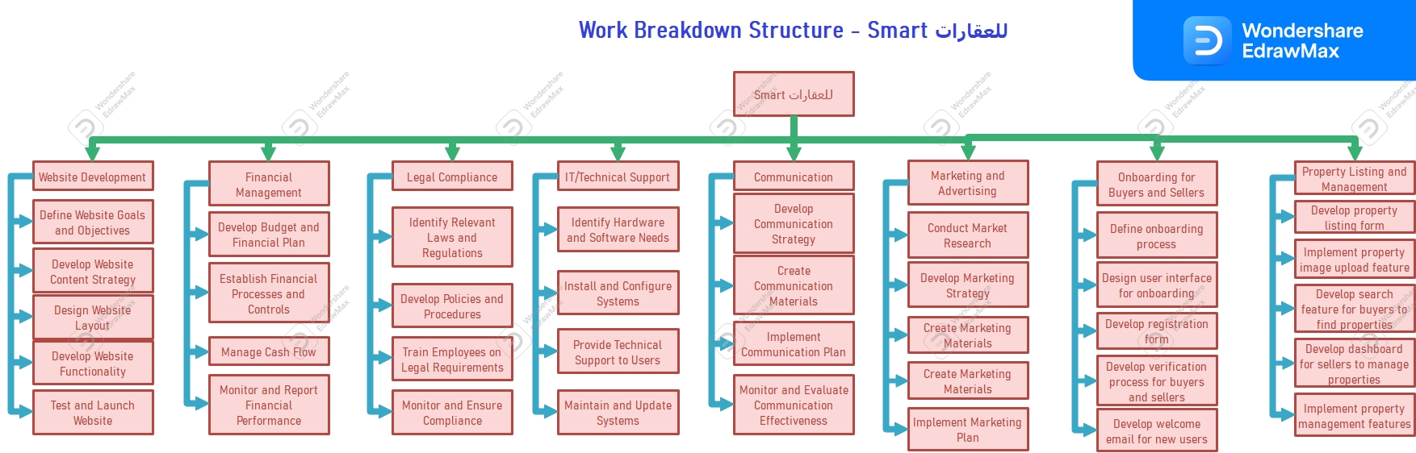

**PERT / Gantt chart**

#### **Gantt chart:**

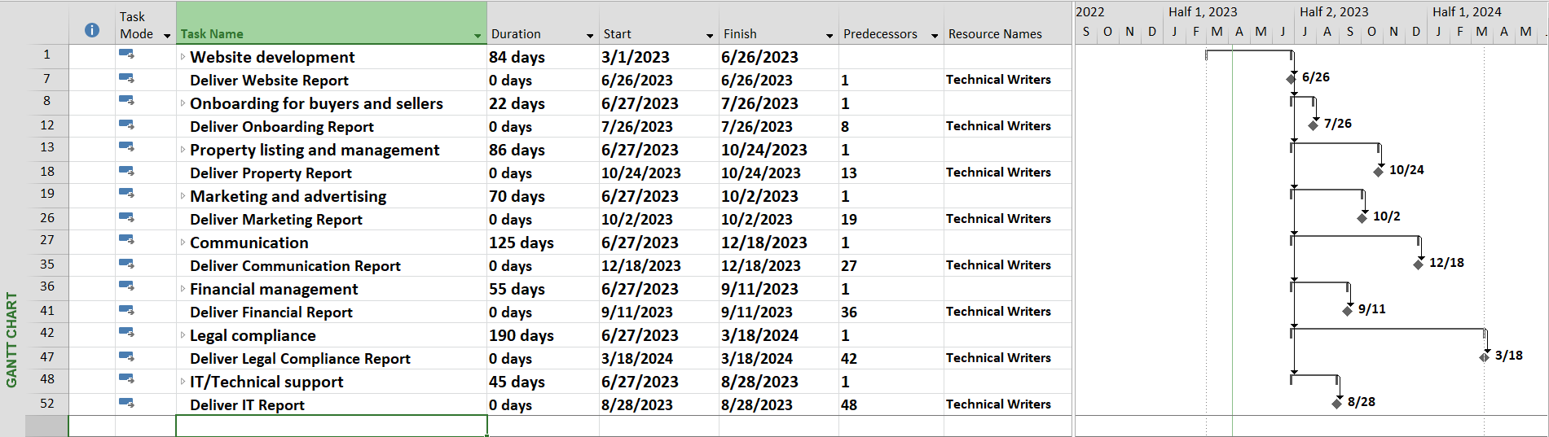

#### **Pert chart:**

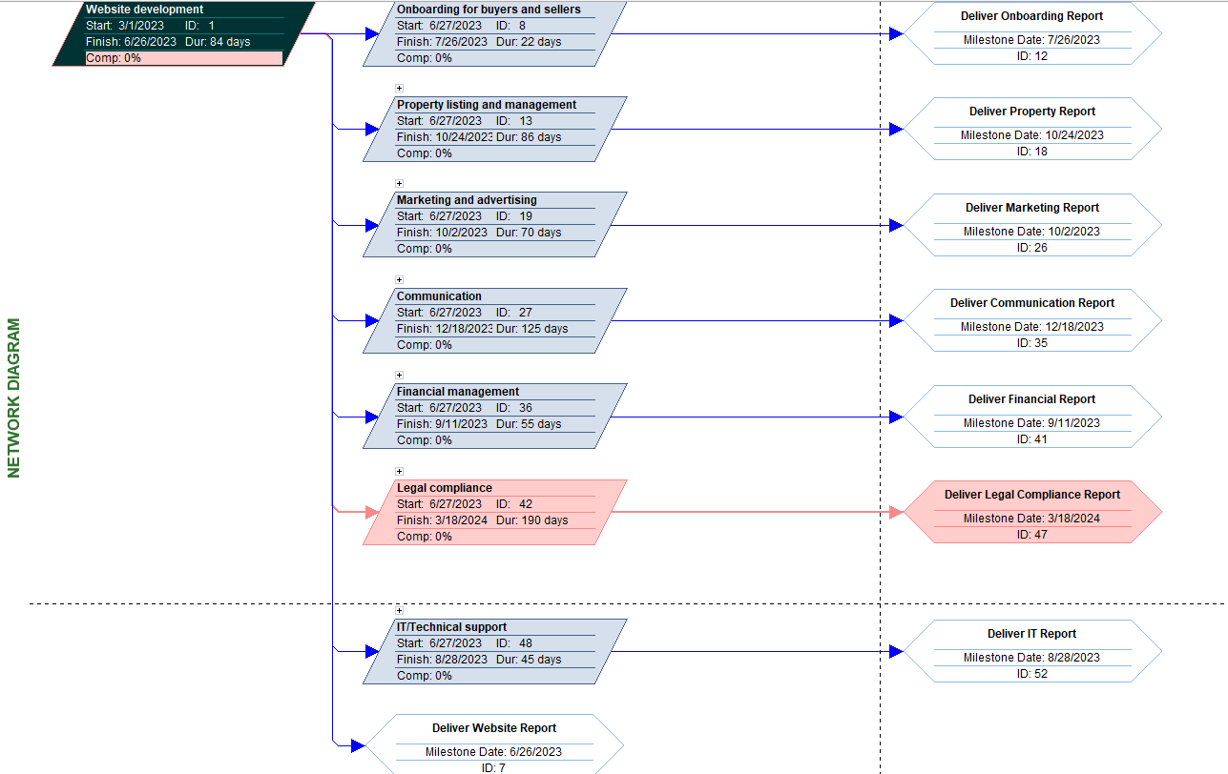

#### **Resource Sheet:**

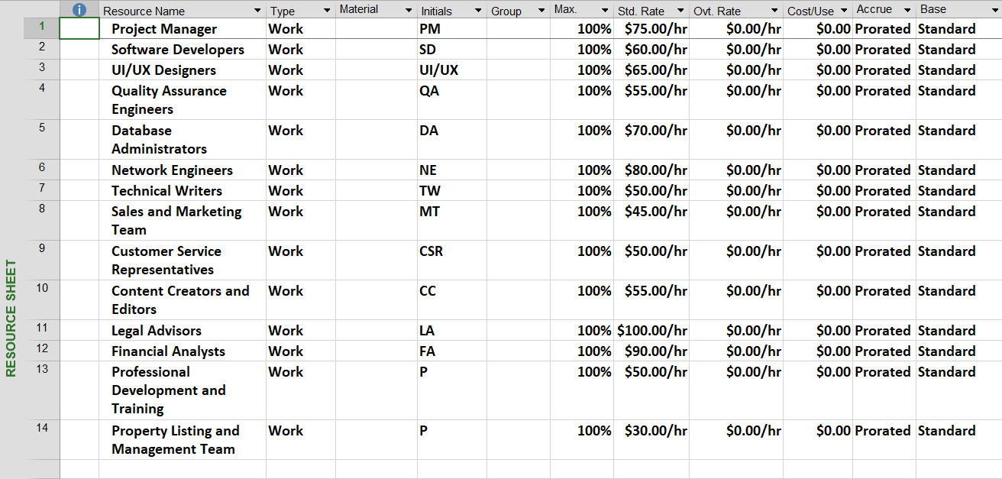

# 7. TESTING PLAN

**To ensure the successful implementation and delivery of the project, the following test plan should be executed:**

1. **Unit Testing:**

* **The development team will conduct unit testing on all individual components and modules of the system to ensure they are functioning as intended.**
* **All identified defects will be logged and reported to the development team for resolution.**

1. **Integration Testing:**

* **Once the individual components and modules have been tested, integration testing will be conducted to test the functionality of the system as a whole.**
* **The testing team will simulate real-world scenarios and test the integration between different components and modules to ensure they are working together seamlessly.**
* **All identified defects will be logged and reported to the development team for resolution.**

1. **System Testing:**

* **Once the integration testing is complete, system testing will be conducted to ensure the system meets all specified requirements and functions as intended.**
* **The testing team will conduct both functional and non-functional testing, including performance, security, and usability testing.**
* **All identified defects will be logged and reported to the development team for resolution.**

1. **Acceptance Testing:**

* **Once system testing is complete, acceptance testing will be conducted with the stakeholders to ensure the system meets their requirements and expectations.**
* **The testing team will work closely with the stakeholders to develop test scenarios and test cases that align with their needs.**
* **All identified defects will be logged and reported to the development team for resolution.**

### Definition of Done:

**The project will be considered done when the following criteria are met:**

* **All requirements and deliverables have been met and approved by the stakeholders.**
* **All identified defects have been resolved and retested.**
* **The system has passed all testing phases, including unit, integration, system, and acceptance testing.**
* **The system is fully deployed and functional in the production environment.**

### Success Criteria:

**The project will be considered successful when the following criteria are met:**

* **The system meets all specified requirements and functions as intended.**
* **The system is fully deployed and operational in the production environment.**
* **The stakeholders are satisfied with the system and its performance.**
* **The system has been delivered on time and within budget.**

**Note: For more information look at the TESTING PLAN folder**

# 8. FEASIBILITY STUDY

**Risk Identification**

1. **Technical Risks - There is a possibility of technical issues during the development phase that could lead to delays or even failure of the project.**
2. **Resource Risks - The team may face issues with resource allocation, such as lack of skilled personnel, unavailability of equipment, or insufficient funding.**
3. **Schedule Risks - There is a possibility that the project may not be completed on time due to unforeseen circumstances such as changes in requirements, delays in delivery of materials, or unavailability of key personnel.**
4. **Security Risks - The system may be vulnerable to security breaches or attacks, leading to loss of data and system failure.**

**Risk Prioritization**

1. **Technical Risks**
2. **Resource Risks**
3. **Schedule Risks**
4. **Security Risks**

**Risk Mitigation**

1. **Technical Risks - The team will conduct regular code reviews, testing, and quality assurance to detect and address technical issues as soon as possible. Additionally, the team will ensure that all code is well documented and follows best practices to avoid technical debt and minimize the risk of failure.**
2. **Resource Risks - The team will develop contingency plans to address resource allocation issues, such as outsourcing certain tasks or re-allocating resources to higher priority tasks. The project budget also will be reviewed regularly to ensure that funding is available for critical tasks.**
3. **Schedule Risks - The team will conduct regular status meetings to identify potential schedule risks and develop contingency plans to mitigate them. The project schedule will be updated regularly to reflect any changes in requirements or other factors that may impact the project timeline.**
4. **Security Risks - The team will conduct regular security reviews and implement security best practices to minimize the risk of security breaches. The team will also develop a plan for responding to security incidents in the event of a breach.**

#### **Prototype**

**To mitigate technical risks and ensure that the project is feasible, the team will develop a working prototype of the system that can be tested and refined throughout the development process. This will allow the team to detect and address technical issues early in the process and ensure that the final product meets the project requirements.**

**Note: For more information look at the FEASIBILITY STUDY folder**

# 9. CONFIGURATION AND VERSION CONTROL

### Process

1. **Creation of a central repository: We will create a central repository where all project and product artifacts will be stored.**
2. **Versioning: Each artifact will be assigned a version number for tracking purposes. This will help us to keep track of changes made to the artifact.**
3. **Branching: We will create different branches in the repository for development, testing, and production. Each branch will have its own set of versioned artifacts.**
4. **Access Control: Access to the repository will be controlled and managed to ensure that only authorized personnel have access to the repository.**
5. **Change Control: Changes made to the artifacts will be tracked and documented in the repository**

### Attributes

1. **Artifact Name: Each artifact will have a unique name to identify it in the repository.**
2. **Artifact Description: A brief description of the artifact will be included to provide context.**
3. **Artifact Version Number: A version number will be assigned to each artifact for tracking purposes.**
4. **Artifact Creator: The name of the person who created the artifact will be recorded.**
5. **Artifact Creation Date: The date and time when the artifact was created will be recorded.**
6. **Artifact Modification Date: The date and time when the artifact was last modified will be recorded.**
7. **Artifact Location: The location of the artifact in the repository will be recorded.**
8. **Branch: The branch to which the artifact belongs will be recorded.**

# 10. TOOLS

1. **Integrated Development Environment (IDE): We will use an IDE to write and debug our code. Examples of IDEs include Visual Studio Code, PyCharm, and Eclipse.**
2. **Version Control System (VCS): We will use a VCS to manage the source code and track changes made to the code. Examples of VCSs include Git, SVN, and Mercurial.**
3. **Issue Tracking System: We will use an issue tracking system to manage and track issues and bugs that are discovered during the project. Examples of issue tracking systems include Jira, Trello, and Asana.**
4. **Project Management Software: We will use project management software to keep track of project milestones, deadlines, and progress. Examples of project management software include Microsoft Project, Asana, and Basecamp.**
5. **Collaboration Tools: We will use collaboration tools to communicate and collaborate with team members. Examples of collaboration tools include Slack, Microsoft Teams, and Zoom.**
6. **Testing Frameworks: We will use testing frameworks to automate and manage our testing process. Examples of testing frameworks include Pytest, Selenium, and JUnit.**
7. **Continuous Integration/Continuous Deployment (CI/CD) Tools: We will use CI/CD tools to automate the build, testing, and deployment process. Examples of CI/CD tools include Jenkins, Travis CI, and CircleCI.**
8. **Database Management System: We will use a database management system to manage and store data for our project. Examples of database management systems include MySQL, PostgreSQL, and MongoDB.**

# 11. Risk Management Plan

1. **Risk Identification:**
   * **Market Demand: Changes in the rental market demand may affect the success of the project.**
   * **Technology Dependencies: Dependencies on external technologies or APIs may lead to delays or limitations.**
   * **Regulatory Compliance: Failure to comply with local regulations and laws regarding property rental may result in legal issues.**
   * **Data Security: Risks associated with data breaches, unauthorized access, and data privacy must be addressed.**
   * **System Performance: Potential issues related to system scalability, response time, and performance may impact user satisfaction**.
2. **Risk Assessment:**
   * **Likelihood and Impact: Assess the likelihood of each risk occurring and the potential impact on the project's objectives.**
   * **Prioritization: Prioritize risks based on their severity and their potential to disrupt the project's timeline, cost, or quality.**
3. **Risk Mitigation Strategies:**
   * **Market Research and Analysis: Conduct thorough market research to anticipate changes in rental demand and adjust the system accordingly.**
   * **Technology Evaluation: Evaluate the reliability, scalability, and compatibility of external technologies before incorporating them into the system.**
   * **Compliance Management: Regularly monitor and update the system to comply with local regulations and laws regarding property rental.**
   * **Data Security Measures: Implement robust security measures, such as encryption, access controls, and regular vulnerability assessments.**
   * **Performance Testing and Optimization: Conduct extensive performance testing to identify and address performance bottlenecks proactively.**
4. **Risk Monitoring and Control:**
   * **Regular Risk Assessment: Continuously monitor and reassess risks throughout the project life cycle, adapting mitigation strategies as needed.**
   * **Communication and Reporting: Maintain open channels of communication with stakeholders to report risks, mitigation efforts, and progress.**
   * **Contingency Planning: Develop contingency plans to address unforeseen risks that cannot be entirely mitigated.**
5. **Roles and Responsibilities:**
   * **Project Manager: Overall responsibility for risk management, including identification, assessment, and mitigation.**
   * **Development Team: Responsible for implementing risk mitigation strategies and following best practices to minimize risks.**
   * **Quality Assurance Team: Conduct regular testing and quality checks to ensure that risks are identified and addressed.**

**By proactively identifying and managing potential risks, the Apartment Rental project can mitigate threats and minimize their impact on the project's success. Regular risk assessment, effective mitigation strategies, and clear roles and responsibilities will help ensure that the project progresses smoothly, delivering a high quality and reliable rental platform for tenants, property owners, and administrators.**

**Note: For more information look at the RISK MANAGEMENT folder**

# 12. ARCHITECTURE

### An Object-Oriented Architectural Pattern

**The Model-View-Controller (MVC)**

#### **Controller**

**In an apartment rental project, the controller is the part responsible for controlling the implementation and management of the various operations of the project. The controller aims to direct the data between the models and the view, so that the process of inputting, extracting and modifying the data stored in the database is controlled.**

**In the case of an apartment project, the controller can include, for example, the following operations:**

**Register users and define their permissions.**

**- Adding, modifying and deleting apartments available for rent.**

**- Adding, modifying and deleting lease contracts and registered tenants.**

**View reports and statistics of rents, payments and arrears.**

**Thus, it can be said that the controller is the main part of the apartment rental project as it controls the interaction between users and the system and the achievement of the required goals.**

#### **Model**

**In an apartment rental project, the Model is the part responsible for handling the data and information stored in the database. The Model aims to define the structure of the data and define the way to deal with it, so that the process of accessing and managing the data is simplified effectively.**

**In the case of an apartment rental project, the Model can be used to represent the different objects in the project, such as apartments, contracts, tenants, owners, and others. In this way, the properties of each object can be defined and the methods for accessing and modifying them can be defined.**

**For example, we might have a Model of Apartments that has the following properties:**

**- Apartment number**

**Apartment address**

**- The number of rooms**

**- The space**

**- The price**

**- Status of the apartment (available or rented)**

**Description of the apartment**

**Thus, the Model can be used to represent all data related to the apartments, and to define ways to access and modify them, to facilitate data management and save time and effort.**

#### **View**

**In the case of an apartment rental project, the View can be used to design the user interface for the project, so that the available apartments and information related to them are displayed, as well as the rental contracts, details of tenants, owners, and other data.**

**Thus, the View can be used to design the user interface in a manner commensurate with the requirements of users and facilitate the process of interacting with the system, by providing multiple functions such as:**

**- View apartments available for rent with their details and photos.**

**View details of existing contracts, contract expiration date, rental value, and others.**

**- The ability to add and modify apartments, contracts, tenants and owners.**

**- Search for available apartments and existing contracts.**

**View reports and statistics of rents, payments and arrears.**

**Thus, it can be said that the View is the second main part of the project for renting apartments, as it controls the design of the user interface and provides the necessary functions for managing data and interacting with the system.**

### System Architecture:

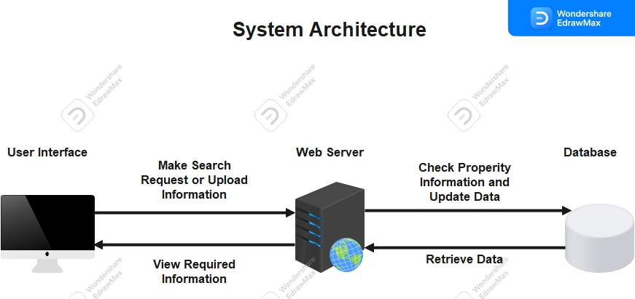

### Database Schema:

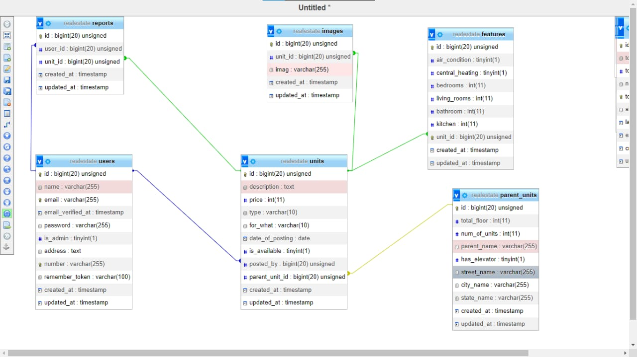

### Sequence Diagram

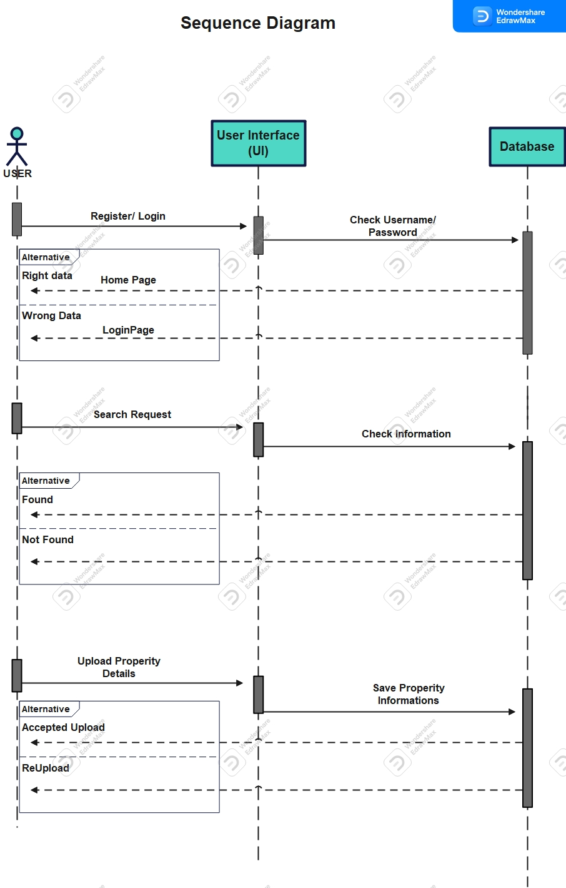

### State Diagram

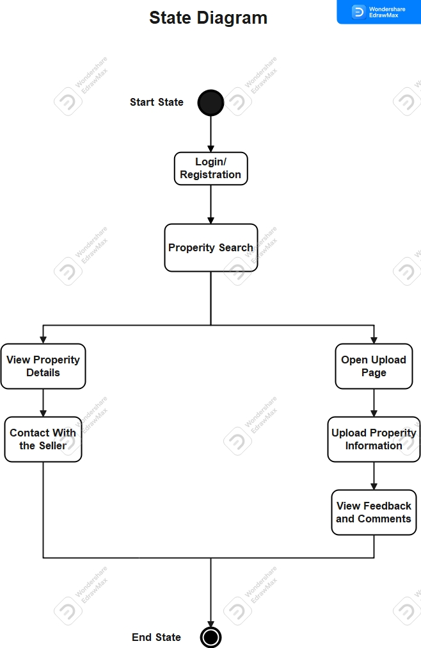

### ER Diagram